CAVE IN
TM
GAME PROGRAM
INSTRUCTIONS

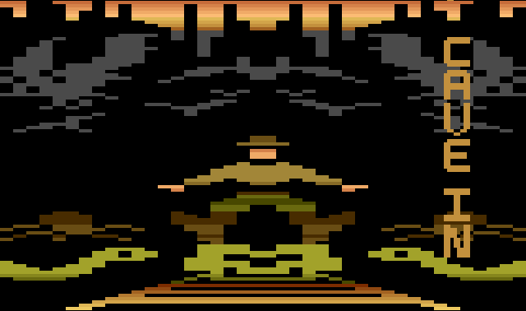



Game Story:

You're an adventurer who has set out to find an ancient lost crown. Legend says the crown was broken into three pieces and hidden in an old abandoned mine. The people that hid the crown did not want it to be found, so they’ve made finding it and reassembling it nearly impossible. The crown can only be reassembled in the ancient throne room, which is also hidden in the mine. Watch out for the traps that have been set for any adventurer who dares try to find the crown – poison arrows may shoot out of the walls, and giant boulders are released to roll you over! As you enter the mine, the entrance caves in and you realize that you're stuck - now you have two things on your mind, finding the lost crown and finding a way out of the mine!



As you start wandering through the mine, you'll encounter hordes of deadly underground creatures that will attack you along the way. Sometimes they will attack very aggressively, be careful! Luckily you’ve packed a gun with you, and there’s an endless supply of ammunition, as long as the gun is in your possession. If you lose too much health, you’ll drop your gun, and the only way to recover it is to find the gun room (which is hidden), or wait for an enemy to drop a gun and a health recharge pack for you. In the advanced levels (Games 2 and 3), you’ll have to find the hidden gun room first, the enemies won’t drop a gun for you until you first discover that room. If you have a gun in your possession, the enemies will drop a health recharge pack by itself, which will give you a slight boost. There is also a watering hole hidden in the mine, if you find it and enter it you will regain all of your strength. If you must face enemies without your gun, you can engage in hand to hand combat, however the enemy will inflict 7 hitpoints of damage before he is destroyed.

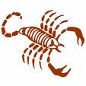

Inside the mine there are four locked gates. You'll have to search the mine to find the three individual keys that open the first three gates. To search a room for a key, simply bump into the wall. Search a room well, however, as all parts of the room with the key may not drop it, so check different areas of each room. If there's a key in that room, you'll automatically pick it up and it will appear in your inventory. The walls of the mine are very unstable, bumping the walls causes a slight tremor in the room. The locked caves were locked for a reason – they’re very unstable. Shooting an enemy inside these caves starts a cave-in inside that room. Watch out for falling rocks! Once you enter a locked cave that has a broken crown piece, you cannot exit the cave until you’ve found that crown piece. Recharge your health before you enter a cave!

Each locked gate has it's own specific key. The fourth gate (the green cave) will unlock only in the presence of the three lost crown pieces. As you find the three pieces of the crown, the inventory status bar will show how many you've collected in the lower left corner of the screen. When you have all three, go to the green cave and find the throne room, which legend also says has the power to bond the three crown pieces together. When you find the throne room, you'll find that it is protected by a guardian that must be killed before you can restore the crown. It is the only enemy in the game that has hitpoints, and if you leave the room before he's been killed, the guardian’s health will recharge back to 100%.

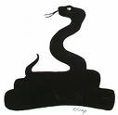

After you have killed the guardian, the crown will appear in the throne room. Run over it to pick it up. You now have what you came for, so you need to run and find your way out of the mine. You'll have to search the mine for a switch that activates a hidden exit. The switch and hidden exit can be found well before you have the completed crown, but you'll find your actual exit is blocked unless you are in possession of the crown. Look very closely for the hidden exit, it’s very easy to overlook!

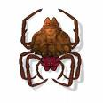

Once you reach the hidden exit and the crown is in your possession, you'll find the path is open to the outside, where you'll exit into the mountain valley and complete your quest.

How to beat the game:

- Find the hidden keys to unlock the locked cave gates
- Find the broken crown pieces hidden in the caves
- Bring the three broken crown pieces to the throne room in the green cave
- Kill the guardian in the green cave, which will reveal the completed crown
- Find the switch that opens the hidden mine exit
- Take the crown to the hidden mine exit to complete your quest

Objects to help you on your quest:

- The Shield, which protects you from enemy attacks
- The underground tunnels, which will quickly take you to opposites sites of the mine
- The Health recharge room, which restores your health to 100%
- The health recharge packs, which give you a small energy boost
- Your gun, which you can use to kill enemies

Game Levels:

There are three selectable game levels that you can choose from before you begin your quest. When the level select screen appears, choose 1, 2, or 3 by pushing up on your joystick. Press fire to begin the game. At any time during the game you can press the reset switch on your console to start over.

Game 1 – Beginner

Enemies move at normal speed and never have a fast attack
No health reduction when changing rooms
Keys are always hidden in the same rooms

Game 2 – Intermediate

Enemies move at normal speed with occasional fast attacks
1 point health reduction when you change rooms, but only after you are down to 3 health blocks left
Key locations are randomized
You start out with no gun - you will have to find it.

Game 3 – Advanced

Enemies move at top speed all the time
1 point health reduction when you change rooms at all times
Key locations are randomized
You start out with no gun - you will have to find it.
Falling rocks in the locked caves will fall twice as fast

Status Bars:

Status/Inventory Bar:
The status bar keeps track of your progress in the game. As you pick up crown pieces, they will appear on the bottom left. As you find the keys, the gun upgrade, and the completed crown, they will appear in your inventory. As you take damage from enemies, your health bar will decrease from right to left.

Crown Pieces Inventory Your Health

Throne Room Status/Inventory Bar:
In the final battle against the guardian in the throne room, the crown piece status on the lower left will change to a health bar for the enemy. Your health status remains on the lower right. The guardian’s health meter runs in the opposite direction as yours.

Guardian’s Health Inventory Your Health

Areas of the Mine:

Watering Hole (Health Recharge Room):
Find this room and recharge your health to 100%.

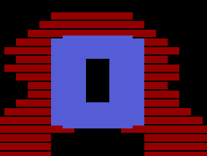

Lava Rooms:
Lava Rooms have extremely hot cave walls that will injure you if you touch them. Walk very carefully through these rooms!

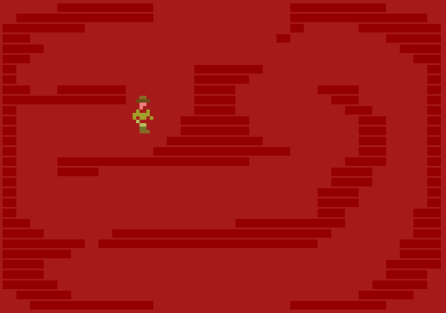

Rockslide Room:
The rockslide room is an area of fallen boulders. If you touch one of the stationary boulders, you’ll slide off! Don’t worry, touching them or falling off of them will not injure you. Beware of rolling boulders that move across the screen, however, as they will injure you.
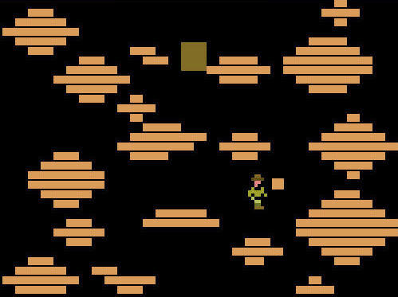

The Rail car:
You may stumble upon the railcar during your quest, which once you jump on you have to ride the length of the track. You’ll move sideways along the path, with boulders dropping above you. If you run into the broken tracks along the way or get hit by a boulder, you will injure yourself. The boulder must hit you to do any damage, it will simply bounce off the rail car.
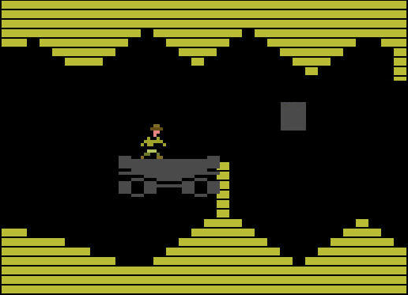
Darkened Mine Shaft:
There is one darkened mine shaft that you’ll have to find your way through in order to reach one of the locked caves. You’ll be carrying a light that lets you see a short distance all around you. You can’t use your gun in the mine shaft, but thankfully there are no enemies to get in your way. If you are carrying the shield, you can keep it inside the mine shaft, but it will be invisible. The same rule applies, if you touch a wall you will drop it.

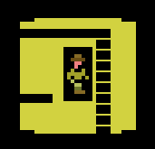

Boulder Room:
There are several boulder rooms in the mine. Avoid the boulder as it rolls toward you – it will do a lot of damage if it hits you!
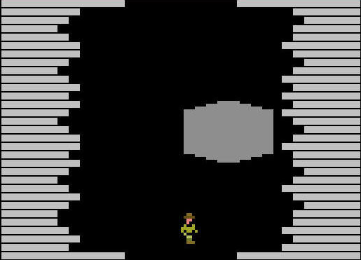

Poison Arrow Room:
You’ll run across a few of these traps in the mine. Watch out for the deadly arrows that shoot from both sides of the room.
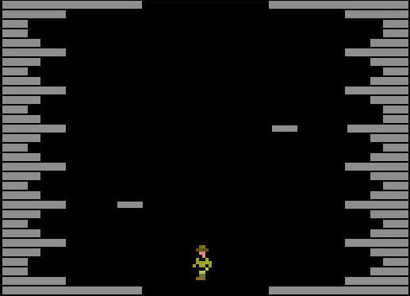

Underground Tunnel:
These operate like warp zones, you’ll enter one of the tunnels and reappear at the other end of the tunnel, which is on the other side of the mine.

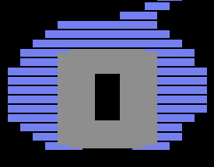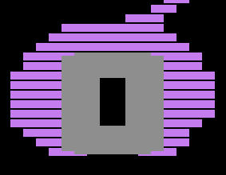

Locked Caves (Yellow, white, and blue):
There are four locked caves in the mine. Three of them contain the crown pieces, and the fourth contains the throne room where you bring all of the crown pieces. These caves are very unstable, shooting enemies will cause a rockslide. Be very careful!

The Evil Eye Cave (Yellow):
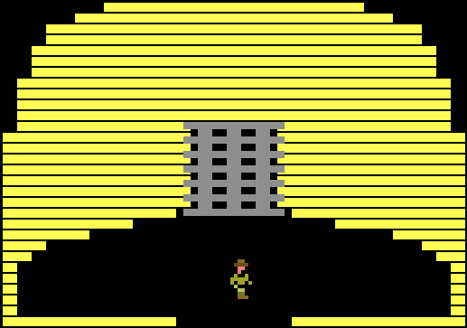

The Spider Cave (White):
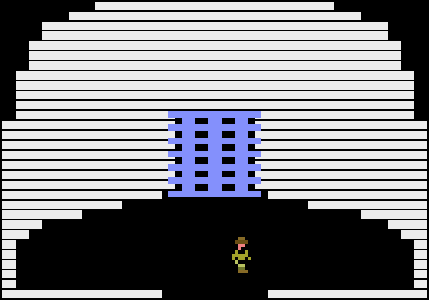

The Skull Cave (Blue):
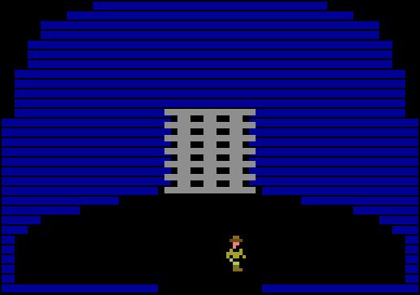

The Green Cave:
The green cave requires that you have all three crown pieces, at which time it will automatically unlock. You’ll find the throne room in this cave that will allow you to complete the crown. Be careful! The throne room is protected by the guardian.

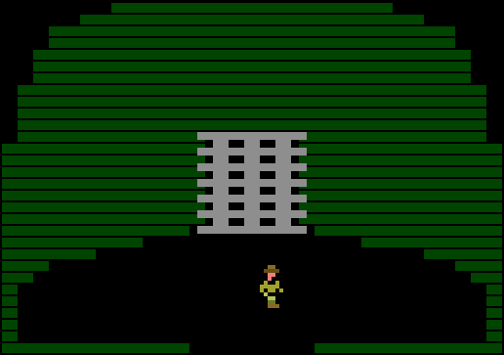

Your Health

You start with 80 units of health. One unit of health (1 block on the screen) represents 10 units of health. For every 10 health units you lose, one block will disappear on the screen.

Here is a chart of how the health system works:
Hit by an enemy: -1 Point
Hit by an obstacle (rock, arrow): -1 Point for each frame you're in contact with the obstacle
Move to a different room (Games 2 & 3): -1 Point
Pick up a health pack: Recharges current block of health points to full, however you will not see a change in your health bar on the screen.
Enter Watering Hole: Recharges your health bar to 100% full.

If you play on Game 2, you’ll lose one point of health each time you change rooms after your health bar is down to 3 blocks or less. If you play on Game 3, you’ll lose one point of health every time you change rooms, regardless of the status of your health bar. Your adventure makes you tired, thirsty, and hungry, so you’ll have to plan trips to the watering hole to replenish your health. Choose your path carefully when you’re low on health! Also, in all 3 game levels, when you get down to 3 blocks of health you’ll move more slowly.

Objects/Inventory Items

The Crown:
After you defeat the guardian, you can pick up the completed crown, which will display in your inventory. Now you have to find your way to the exit!


Keys:
You’ll need to collect three keys to enter the locked caves.

1 2 3

1. Spider Key - Opens White Cave
2. Evil eye Key - Opens Yellow Cave
3. Skull Key - Opens Blue Cave

The Switch:
Pushing this switch will open the hidden exit to the mine. The hidden entrance can be opened at any time during the game, however the exit will be blocked by a rock slide unless you’re carrying the completed crown.


Medical Kit:
Sometimes an enemy will drop a health pack after you kill it. Pick it up to recharge your hit counter. What’s a hit counter? Well, you get 10 enemy hits per health bar block - it resets the hit counter 0, but does not change the length of the health bar on the screen.



Medical Kit/Gun:
Sometimes an enemy will drop a health pack along with a gun. Enemies will only drop a gun after you have first found the hidden gun room and picked it up for the first time.



The Shield:
When you're holding it, enemies cannot harm you. The shield is also useful if you’ve dropped your gun. Press the fire button when an enemy is right on top of you, and you’ll knock the enemy out with your shield. You will drop the shield when you touch a wall or when you enter a locked cave entrance room. The shield will return to it's original location when dropped. You can keep it in the invisible maze rooms, it will be carried behind you. The shield is accessible through a hidden room exit, you’ll have to search for it!



The Gun:
The gun can be used to kill almost all of the enemies in the mine with only one shot. If your health bar drops one block, you will drop the gun. You can retrieve it again by defeating enemies, which will randomly drop a gun powerup/health recharge pack. In Games 2 and 3, you must first find the hidden gun room before enemies will drop a gun for you.



Secrets:
There is a hidden room that will take you directly to the four different cave entrances. This room can be very useful if you need to get to a different part of the mine quickly. Use this room carefully after you fiind it, as it will put your health bar at 50%, regardless of your health status when you entered the room.

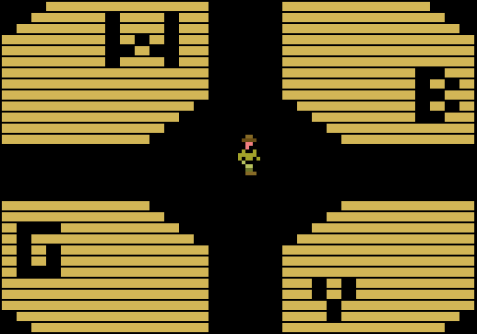

There may also be a master skeleton key that opens all the locked gates, but if that’s true, it would be very well hidden!

That should be all you need to know to complete your quest for the crown. Good luck on your adventure!

Credits

Special thanks are due to the following people, who contributed to this project and helped make this game possible. This list will expand before this manual is published. ☺

Michael Rideout, Nathan Strum, David Exton, espire8, gambler172, MausGames

